A Mini Project Report
On

Movies Review and Analytics
by

Vaibhav Saini (S188002)
Shivam Verma (S188003)

Under the guidance of
Mr. Atul Chaudhari



School of Computer Technology

SAVITRIBAI PHULE PUNE UNIVERSITY
2018-2019
School of Computer Technology
MIT Academy of Engineering, Alandi(D)

Date:

CERTIFICATE

This is to certify that,
Vaibhav Saini (S188002)
Shivam Verma (S188003)

of class S.Y. BTech; have successfully completed their mini project work on “Movies review and analytics’’ at MIT Academy of Engineering in the partial fulfillment of the Graduate Degree course in S.Y. BTech at the School of Computer Technology, in the academic Year 2018-2019 Semester – II.

Mr. Atul Chaudhari Mrs.. Ranjana Badre
Guide Head of the Department
(School of Computer Technology)

Acknowledgements
I would like to express my sincere gratitude to my supervisors Prof. Atul Chaudhari for providing their invaluable guidance, comments and suggestions throughout the course of the Database Management System. I would specially thank Mrs. Ranjana Badre, Dr. Y. J. Bhalerao our priciple for constantly motivating us to work harder, and our friends for helping us with honest feedback. Also, I would like to thank Lab attendant for his assistance in the MITAOE for his help during the preparation of the sample and finally I would like you thank my parent for constant support

Vaibhav Saini (S188002)
Shivam Verma (S188003)

Contents

Sr. No. | Topic |  | Page No.
Chapter-1 | Introduction |  | v
 | 1.1 | Motivation | v
 | 1.2 | Problem Statement | v
 | 1.3 | Framework of the proposed work in project | vi
Chapter-2 | Background Theory |  | viii
 | 2.1 | Technical Feasibility | viii
 | 2.2 | Operational Feasibility | viii
 | 2.3 | Economic Feasibility | ix
Chapter-3 | Software Requirement Specification |  | x
 | 3.1 | Hardware Requirements | x
 | 3.2 | Software Requirements | x
Chapter-4 | Data Flow Diagram |  | xi
Chapter-5 | Implementation |  | xvii
Chapter-6 | Results |  | xxii
Chapter-7 | Limitations |  | xxviii
Chapter-8 | Conclusion |  | xxix

Chapter 1
Introduction

  - Motivation
In this fast-moving world, people have to spend a lot of time to sit back and decide which movie they wish to watch by browsing them one by one from uncountable websites and spend even more time reading their individual ratings and reviews. So we thought of developing a platform for user where they could easily filter out movies based on several criteria, along with getting their detailed description and maintaining a personal watchlist as well.

  - Problem Statement
Develop a web-based application which satisfy the requirement of movies review and analytics as per the user. The user can search for specific movies, filter out movies based on factors like year of release, revenue, cast, rating etc. The user can also add movies to their personal watchlist and see detailed description about any movie. The user can browse the movies and see their description even without creating an account, but is able to add movies to watchlist only if he is logged in.

  - Framework of the proposed work in project

    - Project Overview
The Box Office Mojo is a web-based application which is the source for movies review and ratings to help maximize your movie-going-experience. The easy to use movie revies and ratings are based on score and opinions from respected movie critics, family advocacy groups and movie fans like you. Whether it’s a family movie outing, first date or girls’ night out, our movie review will help you find the perfect movie for any occasion.

    - Project Description
This project is aimed at developing an online Movies review and ratings platform. The entire project has been developed keeping in mind the view the distributed client server computing technology.
The Box Office Mojo is a web-based application which is the source for movies review and ratings to help maximize your movie-going-experience. The easy to use movie reviews and ratings are based on score and opinions from respected movie critics, family advocacy groups and movie fans like you. Whether it’s a family movie outing, first date or girls’ night out, our movie review will help you find the perfect movie for any occasion.

The project has been planned to have the view of distributed architecture, with centralized storage of the database. The application for the storage of the data has been planned. The front-end UI has been developed using HTML, CSS and JavaScript while the backend is using PHP as server side scripting.
The database connectivity is planned using the “MongoDB extension for PHP” methodology. The standards of security and data protective mechanism have been given a big choice for proper usage.
The application takes care of different modules and their associated reports, which are produced as per the applicable strategies and standards that are put forwarded by the administrative staff.
The entire project has been developed keeping in mind the view of the distributed client server computing technology. The user interfaces are browser unspecific to give distributed accessibility for the overall system. The internal database has been selected as MongoDB v4.0.5.
The basic constructs of database, collections and documents have been exploited to provide higher consistency and reliability for the data storage. The MongoDB was a choice as it provides the constructs of unstructured data along with high-level reliability and security. The total front end was dominated using the HTML, CSS, Js technologies. At all required levels, appropriate care was taken to check that the system manages the data consistency with proper queries and validations.
The database connectivity was planned using the latest “MongoDB extension for PHP technology provided by MongoDB ecosystem community. The authentication and authorization were crosschecked at all the relevant stages. The user level accessibility has been restricted into two zones namely guest and authentic user.

Chapter 2
Background Theory

  - Technical Feasibility
The technical issue usually raised during the feasibility stage of the investigation includes the following:
- Does the necessary technology exist to do what is suggested?
- Do the proposed equipment have the technical capacity to hold the data required to use the new system?
- Will the proposed system provide adequate response to inquiries, regardless of the number or location of users?
- Can the system be upgraded if developed?
- Are there technical guarantees of accuracy, reliability, ease of access and data security?

Earlier no system existed to cater to the needs of ‘Secure Infrastructure Implementation System’. The current system developed is technically feasible. It is a web-based user interface for audit workflow at NIC-CSD. Thus, it provides an easy access to the users. The database’s purpose is to create, establish and maintain a workflow among various entities in order to facilitate all concerned users in their various capacities or roles. Permission to the users would be granted based on the roles specified. Therefore, it provides the technical guarantee of accuracy, reliability and security.
The software and hard requirements for the development of this project are not many and are already available in-house at NIC or are available as free as open source. The work for the project is done with the current equipment and existing software technology.
Necessary bandwidth exists for providing a fast feedback to the users irrespective of the number of users using the system.

  - Operational Feasibility
Proposed projects are beneficial only if they can be turned out into information system that will meet the organization’s operating requirements. Operational feasibility aspects of the project are to be taken as an important part of the project implementation. Some of the important issues raised are to test the operational feasibility of a project includes the following:
- Is there sufficient support for the management from the users?
- Will the system be used and work properly if it is being developed and implemented?
- Will there be any resistance from the user that will undermine the possible application benefits?

This system is targeted to be in accordance with the above-mentioned issues. Beforehand, the management issues and user requirements have been taken into consideration. So, there is no question of resistance from the users that can undermine the possible application benefits.
The well-planned design would ensure the optimal utilization of the computer resources and would help in the improvement of performance status.

  - Economic Feasibility
A system can be developed technically and that will be used if installed must still be a good investment for the organization. In the economical feasibility, the development cost in creating the system is evaluated against the ultimate benefit derived from the new systems. Financial benefits must equal or exceed the costs.
The system is economically feasible. It does not require any addition hardware or software. Since the interface for this system is developed using the existing resources and technologies available at NIC, There is nominal expenditure and economical feasibility for certain.

Chapter 3
Software and Hardware requirnemnt specification
  - Hardware Requirement
For our project we required a laptop which having minimum of 4 GB of RAM and minimum 1.2 GHz of clock speed. We also required a good internet connection for that a router is required and minimum 5 GB of storage space required so all requirement are as follow
- Laptop or Desktop
- 4 GB RAM
- 5 GB storage capacity
- Router or Ethernet cable with network connection
- 1.2 GHz Clock Speed

  - Software Requirement
- OS: WINDOWS (7 /8 / 10) / MacOS / Linux
- PHP v7.2.x
- MongoDB Community Server Edition v4.0.5

Chapter 4
Data Flow Diagram
Data flow diagram is graphical tool used to describe and analyze movement of data through a system. These are the central tool and the basis from which the other components are developed. The transformation of data from input to output, through processed, may be described logically and independently of physical components associated with the system. These are known as the logical data flow diagrams.
The physical data flow diagrams show the actual implements and movement of data between people, departments and workstations. A full description of a system actually consists of a set of data flow diagrams. Using two familiar notations Yourdon, Game and Samson notation develops the data flow diagrams. Each component in a DFD is labeled with a descriptive name. Process is further identified with a number that will be used for identification purpose.
The development of DFD’S is done in several levels. Each process in lower level diagrams can be broken down into a more detailed DFD in the next level. The lop-level diagram is often called context diagram. It consists a single process bit, which plays vital role in studying the current system. The process in the context level diagram is exploded into other process at the first level DFD.
The idea behind the explosion of a process into more process is that understanding at one level of detail is exploded into greater detail at the next level. This is done until further explosion is necessary and an adequate amount of detail is described for analyst to understand the process.
Larry Constantine first developed the DFD as a way of expressing system requirements in a graphical from, this lead to the modular design.
A DFD is also known as a “bubble Chart” has the purpose of clarifying system requirements and identifying major transformations that will become programs in system design. So it is the starting point of the design to the lowest level of detail. A DFD consists of a series of bubbles joined by data flows in the system.

  - DEF Symbol
In the DFD, there are four symbols
- A square defines a source(originator) or destination of system data
- An arrow identifies data flow. It is the pipeline through which the information flows
- A circle or a bubble represents a process that transforms incoming data flow into outgoing data flows.
- An open rectangle is a data store, data at rest or a temporary repository of data

Process that transforms data flow.

Source or Destination of data

Data flow
Data Store

  - Context Diagram
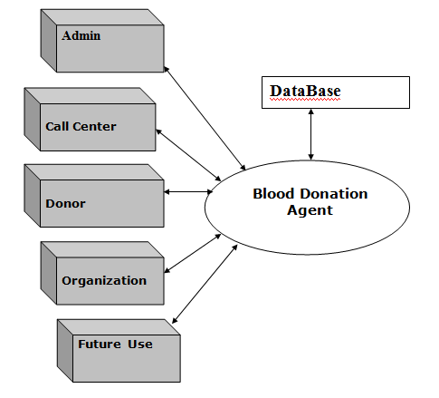

  - First Level DEF
    - Admin Module

Admin

login

Login data

View of value Abilities details

Value Abilities Table

    - User Module

Call Center

Login

updating and
editing

Value Abilities Table

    - For Donor Operation
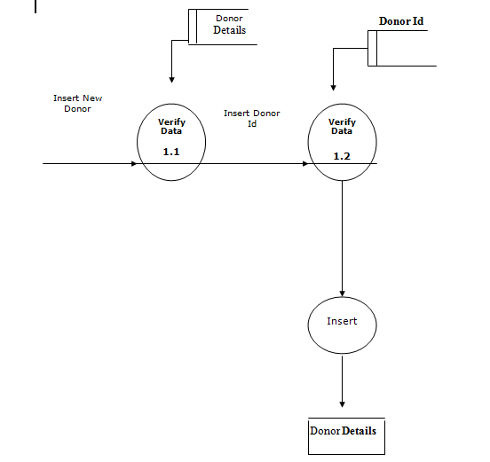

    - Work flow of all Modules
Administrator

Logs In

Call Center

Organization

Various Reports Generated the Donar

View Random Information for the App Donar

Donor Report

Blood Details

Call Center Report

Operator Report

Donar

Appointment Details

Chapter 5
Implimentation
  - Tool Used
- WAMP server
- HTML
- CSS
- JavaScript
- PHP
- Bootstrap
- MongoDB
- VS Code

    - HTML
HTML stands for Hypertext Markup Language, and it is the most widely used language to write Web Pages.
- Hypertext refers to the way in which Web pages (HTML documents) are linked together. Thus, the link available on a webpage is called Hypertext.
- As its name suggests, HTML is a Markup Language which means you use HTML to simply "mark-up" a text document with tags that tell a Web browser how to structure it to display.
Originally, HTML was developed with the intent of defining the structure of documents like headings, paragraphs, lists, and so forth to facilitate the sharing of scientific information between researchers.
Now, HTML is being widely used to format web pages with the help of different tags available in HTML language.

    - CSS
Cascading Style Sheets, fondly referred to as CSS, is a simple design language intended to simplify the process of making web pages presentable.
CSS handles the look and feel part of a web page. Using CSS, you can control the color of the text, the style of fonts, the spacing between paragraphs, how columns are sized and laid out, what background images or colors are used, layout designs,variations in display for different devices and screen sizes as well as a variety of other effects.
CSS is easy to learn and understand but it provides powerful control over the presentation of an HTML document. Most commonly, CSS is combined with the markup languages HTML or XHTML.

    - JavaScript
JavaScript is a dynamic computer programming language. It is lightweight and most commonly used as a part of web pages, whose implementations allow client-side script to interact with the user and make dynamic pages. It is an interpreted programming language with object-oriented capabilities.
JavaScript was first known as LiveScript, but Netscape changed its name to JavaScript, possibly because of the excitement being generated by Java. JavaScript made its first appearance in Netscape 2.0 in 1995 with the name LiveScript. The general-purpose core of the language has been embedded in Netscape, Internet Explorer, and other web browsers.

    - PHP
PHP started out as a small open source project that evolved as more and more people found out how useful it was. Rasmus Lerdorf unleashed the first version of PHP way back in 1994.
- PHP is a recursive acronym for "PHP: Hypertext Preprocessor".
- PHP is a server side scripting language that is embedded in HTML. It is used to manage dynamic content, databases, session tracking, even build entire e-commerce sites.
- It is integrated with a number of popular databases, including MongoDB, MySQL, PostgreSQL, Oracle, Sybase, Informix, and Microsoft SQL Server.
- PHP is pleasingly zippy in its execution, especially when compiled as an Apache module on the Unix side. The MongoDB server, once started, executes even very complex queries with huge result sets in record-setting time.
- PHP supports a large number of major protocols such as POP3, IMAP, and LDAP. PHP4 added support for Java and distributed object architectures (COM and CORBA), making n-tier development a possibility for the first time.
- PHP is forgiving: PHP language tries to be as forgiving as possible.
- PHP Syntax is C-Like.

    - MongoDB
A database is a separate application that stores a collection of data. Each database has one or more distinct APIs for creating, accessing, managing, searching and replicating the data it holds.
Other kinds of data stores can also be used, such as files on the file system or large hash tables in memory but data fetching and writing would not be so fast and easy with those type of systems.
A NoSQL (originally referring to "non SQL" or "non relational") database provides a mechanism for storage and retrieval of data that is modeled in means other than the tabular relations used in relational databases. Motivations for this approach include: simplicity of design, simpler "horizontal" scaling to clusters of machines (which is a problem for relational databases), and finer control over availability. The data structures used by NoSQL databases (e.g. key-value, wide column, graph, or document) are different from those used by default in relational databases, making some operations faster in NoSQL. The particular suitability of a given NoSQL database depends on the problem it must solve. Sometimes the data structures used by NoSQL databases are also viewed as "more flexible" than relational database tables.
MongoDB is a cross-platform document-oriented database program. Classified as a NoSQL database program, MongoDB uses JSON-like documents with schemata. MongoDB is developed by MongoDB Inc. and licensed under the Server-Side Public License (SSPL).
Main features:
- Ad hoc queries:
MongoDB supports field, range query, and regular expression searches. Queries can return specific fields of documents and also include user-defined JavaScript functions. Queries can also be configured to return a random sample of results of a given size.
- Indexing:
Fields in a MongoDB document can be indexed with primary and secondary indices.
- Replication:
MongoDB provides high availability with replica sets. A replica set consists of two or more copies of the data. Each replica set member may act in the role of primary or secondary replica at any time. All writes and reads are done on the primary replica by default. Secondary replicas maintain a copy of the data of the primary using built-in replication. When a primary replica fails, the replica set automatically conducts an election process to determine which secondary should become the primary. Secondaries can optionally serve read operations, but that data is only eventually consistent by default.
- Load balancing:
MongoDB scales horizontally using sharding. The user chooses a shard key, which determines how the data in a collection will be distributed. The data is split into ranges (based on the shard key) and distributed across multiple shards. (A shard is a master with one or more replicas.). Alternatively, the shard key can be hashed to map to a shard – enabling an even data distribution. MongoDB can run over multiple servers, balancing the load or duplicating data to keep the system up and running in case of hardware failure.
- File storage:
MongoDB can be used as a file system, called GridFS, with load balancing and data replication features over multiple machines for storing files.This function, called grid file system, is included with MongoDB drivers. MongoDB exposes functions for file manipulation and content to developers. GridFS can be accessed using mongofiles utility or plugins for Nginx and lighttpd. GridFS divides a file into parts, or chunks, and stores each of those chunks as a separate document.
- Aggregation:
MongoDB provides three ways to perform aggregation: the aggregation pipeline, the map-reduce function, and single-purpose aggregation methods. Map-reduce can be used for batch processing of data and aggregation operations. But according to MongoDB's documentation, the Aggregation Pipeline provides better performance for most aggregation operations.
The aggregation framework enables users to obtain the kind of results for which the SQL GROUP BY clause is used. Aggregation operators can be strung together to form a pipeline – analogous to Unix pipes. The aggregation framework includes the $lookup operator which can join documents from multiple documents, as well as statistical operators such as standard deviation.

- Transactions:
Support for multi-document ACID transactions was added to MongoDB with the General Availability of the 4.0 release in June 2018.

Chapter 6
Result
So here are some Screen shots of the website
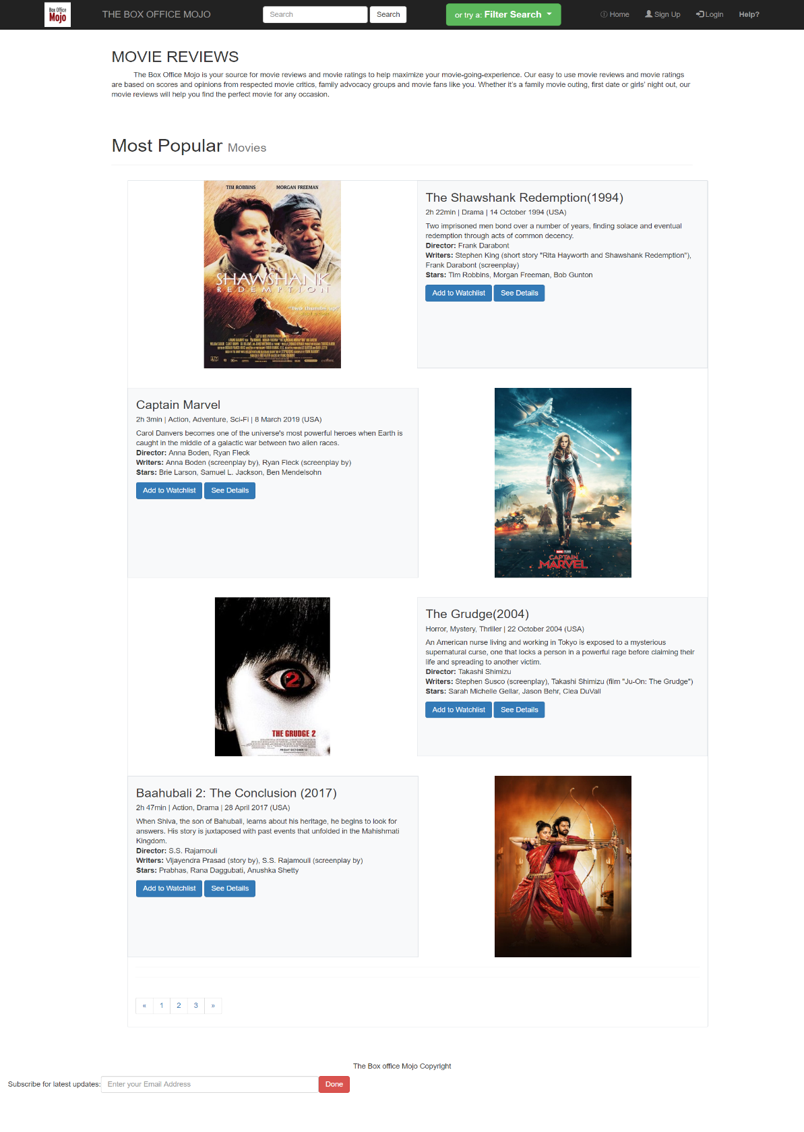
Fig 1- Home Page
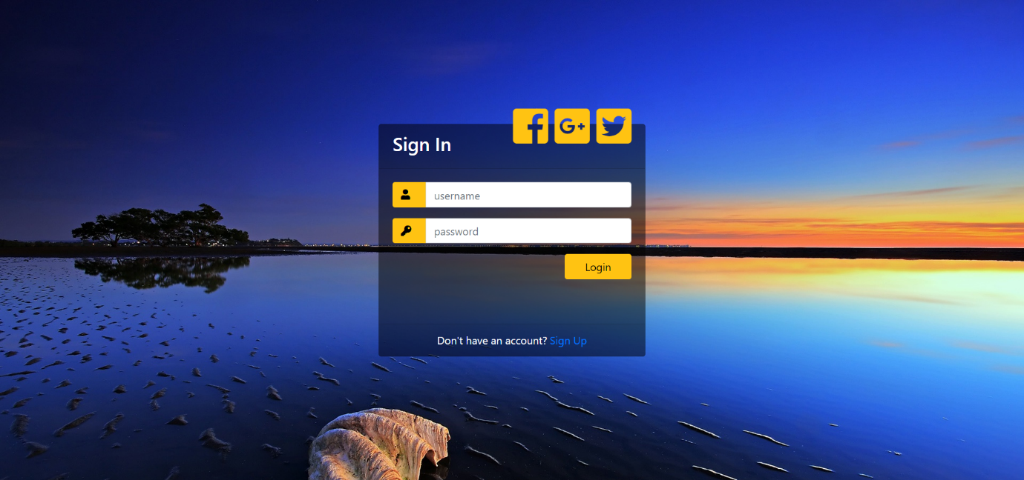
Fig 2- Login Page


Fig 3- Sign-Up page

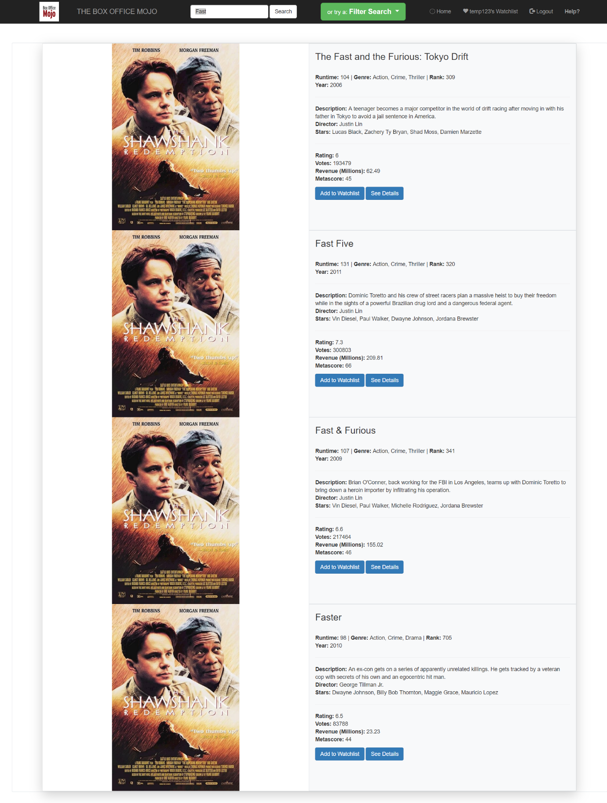
Fig 4- Search results

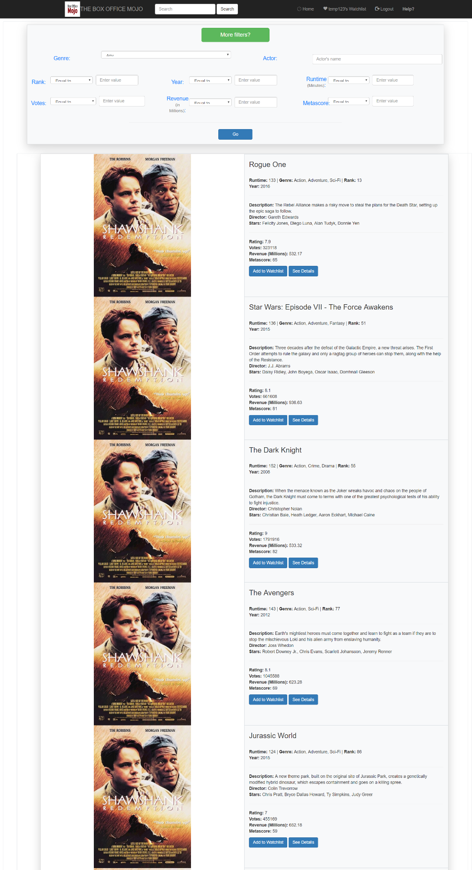

Fig 5- Filtered Search

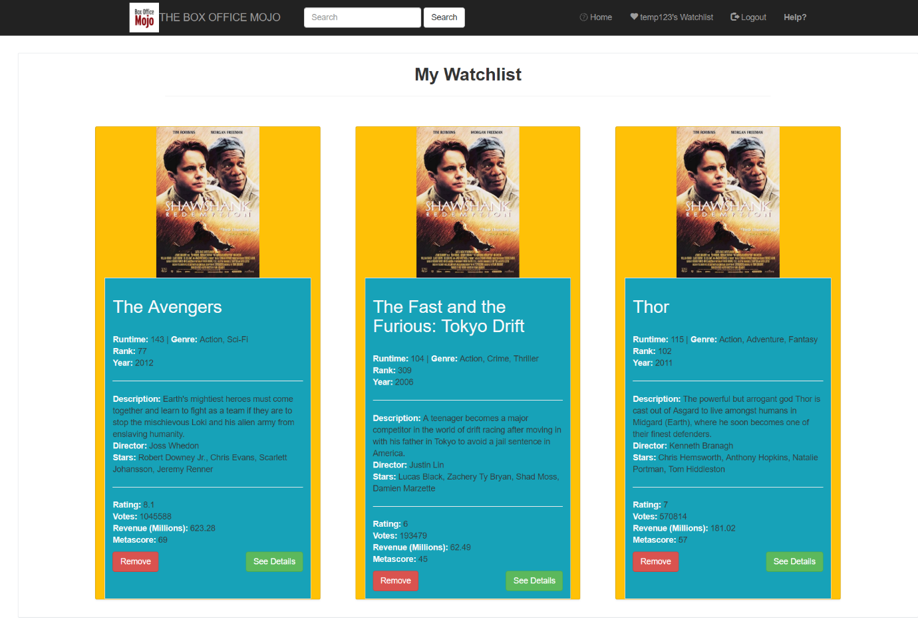
Fig 6- User’s personal watchlist

Chapter 7
Limitation

- Unlike other websites we have fixed star rating due to some constraints, so this may reduce the functionality of our project .

- Also we have made use of a dataset in json format, so we haven’t used a lot of data but worked on just the dataset. Hence there may not be every movie present in our database to access.

- Use of single image in search results may increase difficulty for user to find their movie through search bar

- User cannot update his/her info after registering at the initial stage

References

- MongoDB
https://en.wikipedia.org/wiki/MongoDB

- MongoDB documentation
https://docs.mongodb.com/

- PHP docs
https://php.net/manual/en/class.mongodb-driver-manager.php

- HTML, CSS, Js, Bootstrap
https://www.w3schools.com/

